OSSP (Operating Systems And Systems Programming) - 25CS2104E
(SKILL Content Delivery Concepts)

SKILL 3B :
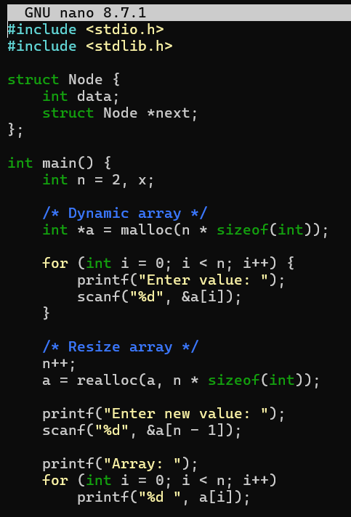
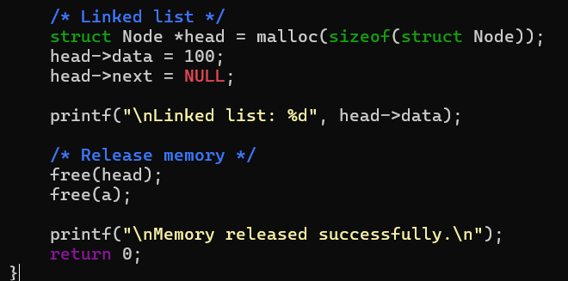
OUTPUT :
